SESSINON-5 SENSITIVITY ANALYSIS

**SESSION-5**

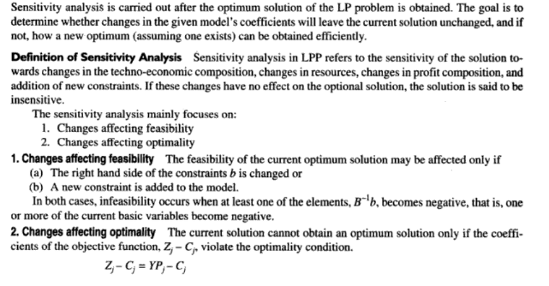

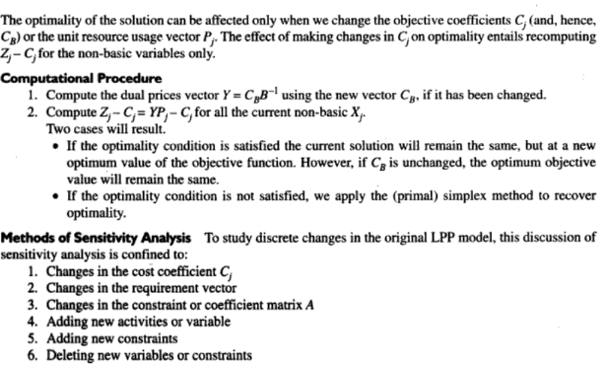

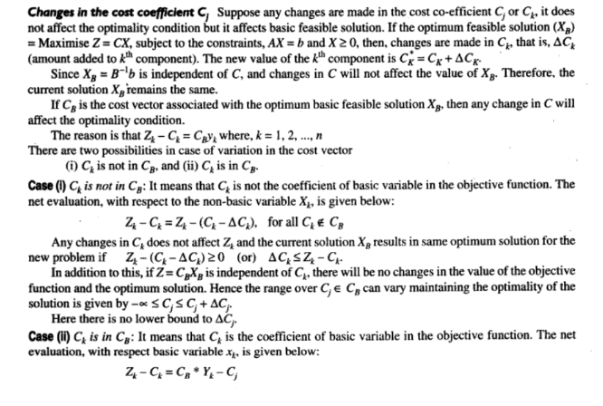

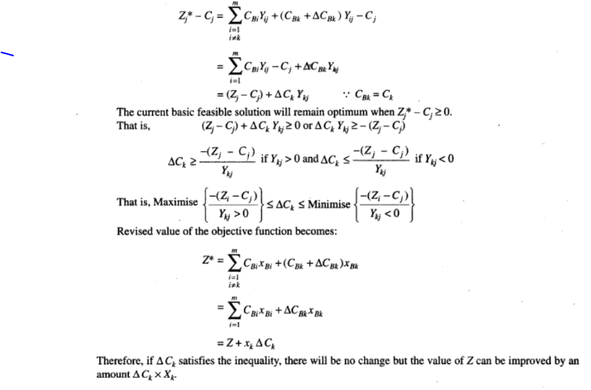

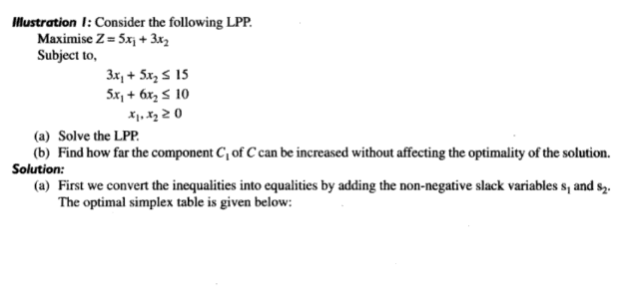

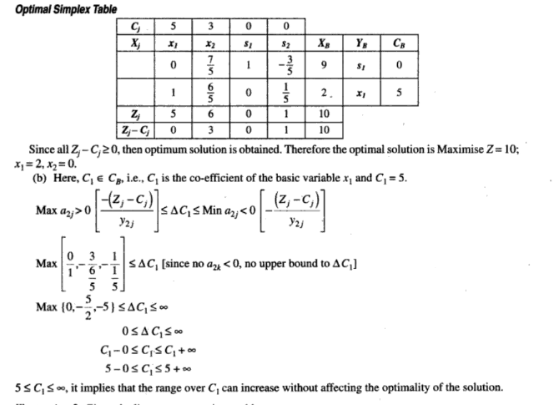

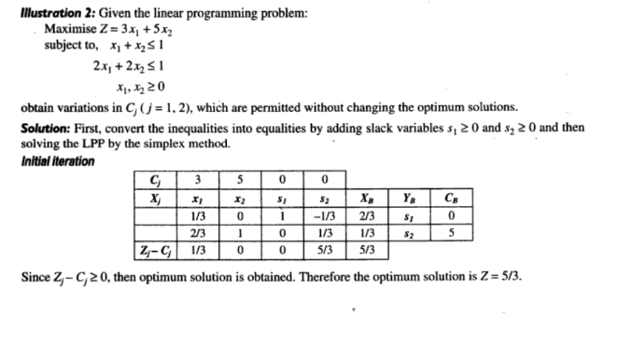

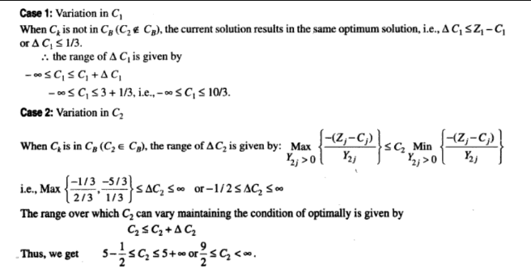

**PROBLEMS:**

**1. Solve the problem and discuss sensitivity analysis of changing c vector(cost values of decision variables**

**Maximize z = 2 $x_{1}+3x_{2}$,**

**subject to $x_{1}+3x_{2}≤6$,**

**3 $x_{1}+2x_{2}≤6$,**

**and $x_{1}, x_{2}≥0.$**

**2. Solve using the Simplex method and discuss sensitivity analysis of changing c vector(cost values 0f decision variables**

**Maximize z = 16 x1 + 15x2 ,**

**Subject to:  40x1 +31x2  ≤ 124 ,  – x1­ + x2 ≤ 1 , x1 ≤ 3 , x1, x2 ≥ 0.**